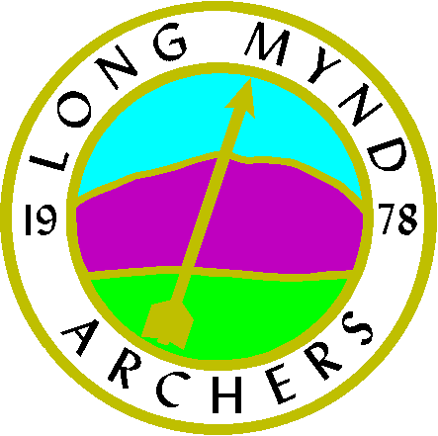

LONG MYND ARCHERS

WINTER 2020

Application to join a beginner’s course in archery organized by the above club.

Title Mr. Mrs., Miss Other Name……………………………………………………..

Address………………………………………………………………………………………

………………………………………………………………………………………………..

Post Code……………………………………………… Telephone………………………

Mobile…………………………………………………… Email……………………………

Height…………………………………………………… Naturally Left / Right handed

The parents or guardians of under18s must sign the consent section of this form. Any child under the age of 8 must be accompanied by their parent/guardian at all times…..

Parental consent: I the undersigned hereby consent to the above named person joining a beginner’s course in Archery with the Long Mynd Archers. I hereby confirm that I am the applicant’s Parent/Guardian.

Signed……………………………………………………….. Date…………………………………….

Please list below any Disabilities, Learning or Medical conditions, which you believe may affect your ability to take part in Archery. (This information will be treated in absolute confidence and will only be used by your coaches to determine the most appropriate equipment and teaching styles to meet your needs)

…………………………………………………………………………………………………………………………………………………..

…………………………………………………………………………………………………………………………………………………

Please return this form with a cheque for £60.00 payable to Long Mynd Archers: to:

Mrs. S Williamson, Chelmick Forge, Chelmick, Church Stretton, SHROPSHIRE SY6 7HA

or BACS using the ref Beginners Barclays, Longmynd Archers, 20-77-85, 50587346

Course dates are all Sundays 2.00 - 4 .00 February 2, 9 & 23 March 1, 8 & 15
Course MUST be finished within 8 Sundays
Eaton Manor, Eaton under Heywood, Church Stretton SY6 7DH

Signed…………………………………………………… Date…………………………………………

Where possible coaching is given by qualified GNAS coaches. However, from time to time, Junior Assistant Coaches, trainee level 1 coaches and un-qualified archers may be involved in coaching and teaching. The GNAS accept no responsibility in this regard, save its statutory liability in respect of personal injury or death caused by negligence of the GNAS. If you have any objections or concerns about this, please inform the club officer in charge prior to the relevant coaching or instruction session.

